Before we get to the instructions, I will review a few important features in Excel (I already went over these in the tutorial). I will also go over a few a few features that I have not mentioned before. We will be making changes to the weekly ledger in these instructions.

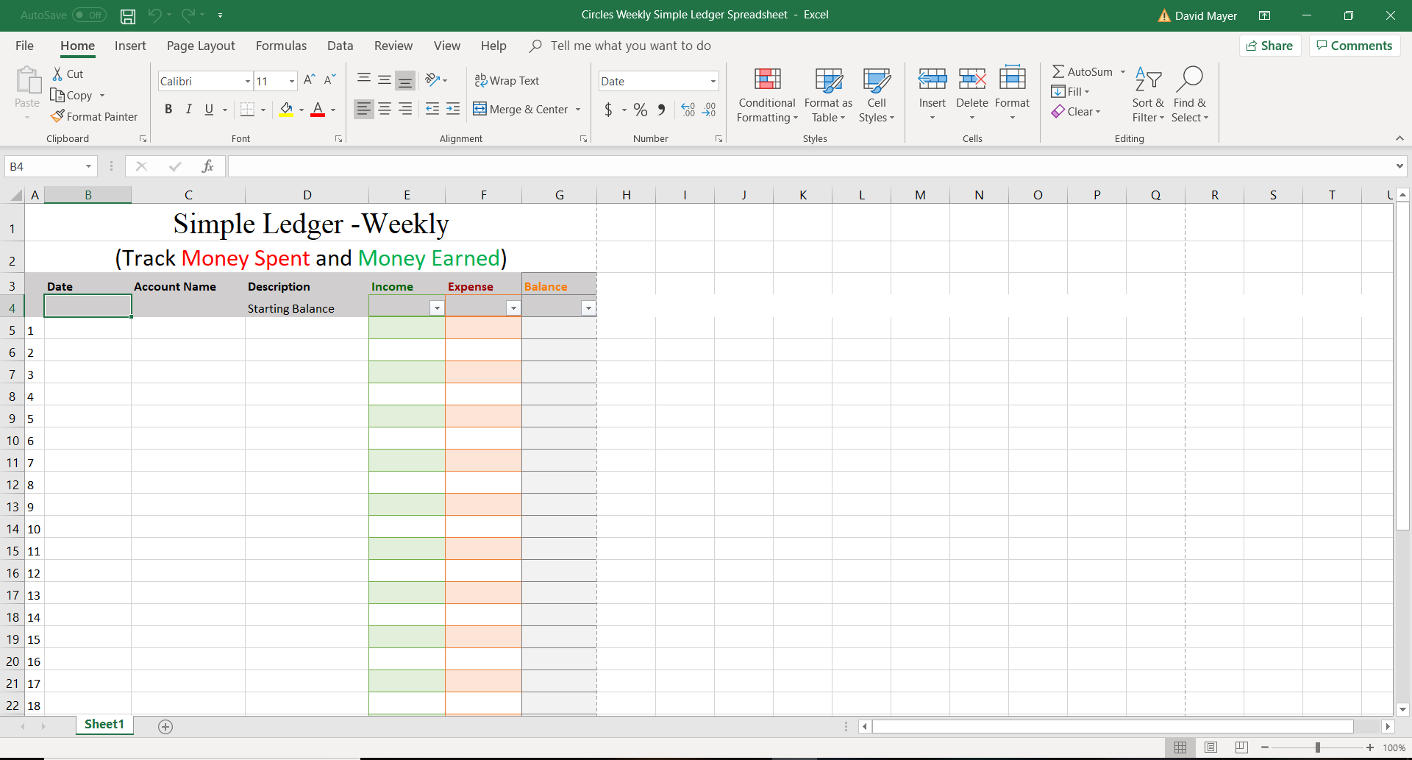
1
2
#1: This “Font tab” is important; it can help you change most issues with how your text appears. The “Wrap Text” and “Merge and Center” are good at fixing things that the Font tab can’t handle. “Wrap Text” drags text down to the next line instead of keeping everything on one line.
#2: Remember, you need to click on the Cell containing the text you want to modify. In this case, left click Starting Balance if you want to change that cell. On the next page, I’ll show you an example.

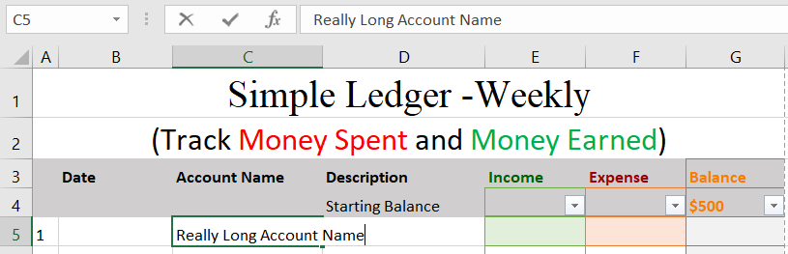

Here, the account name is too big to fit into the box. We can fix this in a variety of ways, and you can decide which way is the most helpful.
Normally, when the text is too big for the cell, you can only see the full text when you click on the cell.

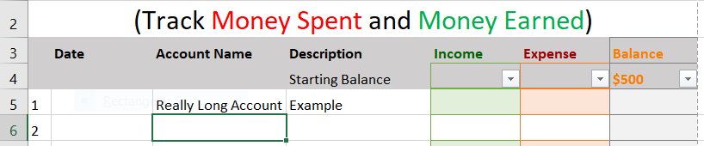

I typed in the description for the account “Really Long Account Name”. My description shows that the account is just an example. You can see that the “Name” in Really Long Account Name doesn’t even show up, because the cell is too small.
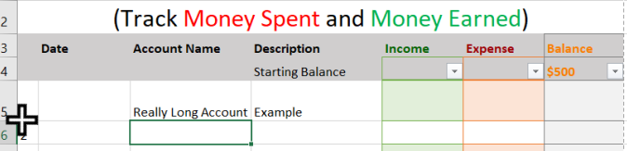

When your cursor gets close enough the line between 5 and 6, it will flatten out (The normal cursor is pictured). After this cursor flattens out, you can click and hold to drag the cell to change size. Here, I made the cell taller, but it didn’t change anything.
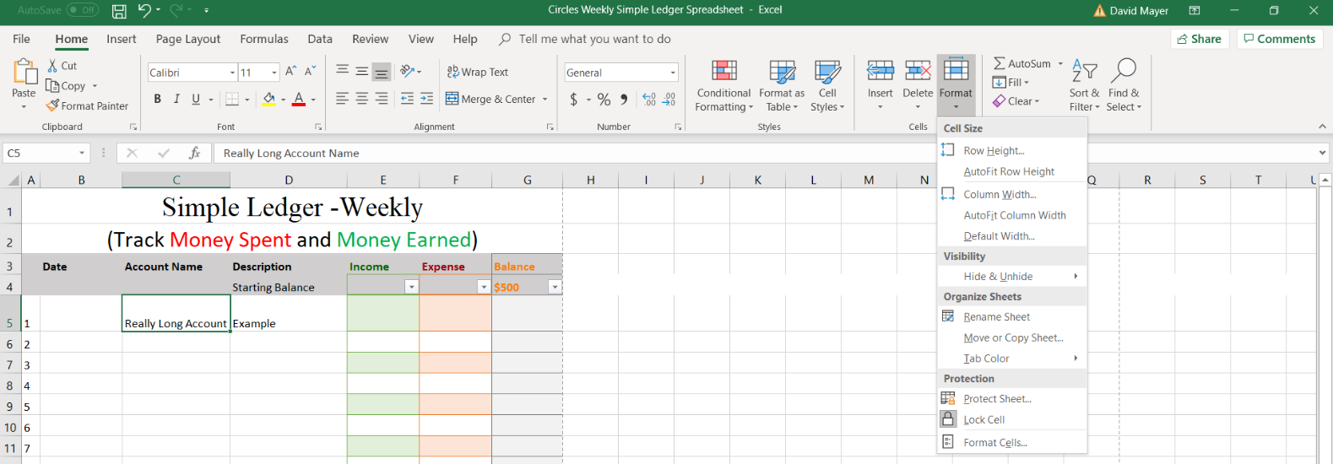
1
2
3

If you are having trouble changing the size with your cursor, you can use the long but reliable method of:
#1 – Click the cell.
#2 – Click “Format”.
#3 – Select either “Row Height...” or “Column Width...”.
Finally, you can pick whatever size you wish for either the row height or the column width. If you increase the column width in this example, you can display the full account name.
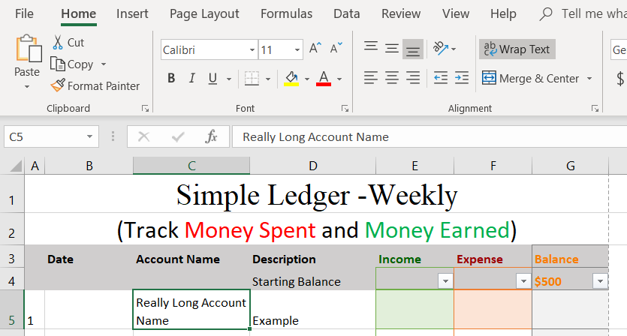

Since I have already increased the row height, I went ahead and selected “Wrap Text”. This lets your text start a new line after it reaches the end of the cell. On the next page, I’ll go over copy and paste.
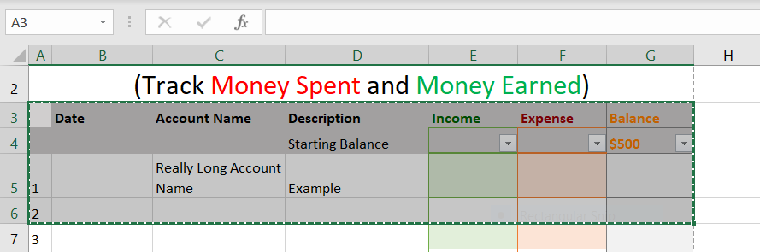

To select multiple cells, start by clicking and holding in the upper-left cell of the selection. Here, I clicked in the red circle. Then I drug my mouse to the lower-right corner without letting go of the mouse left click button. After the whole area was highlighted, I could let go of the mouse.
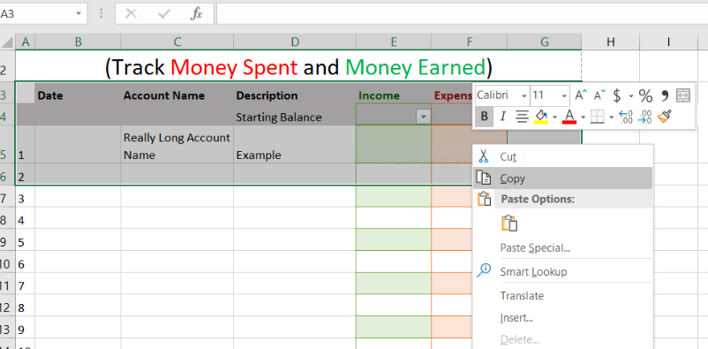
Then, right click anywhere in the highlighted section to bring up the special menus. Click “Copy”.
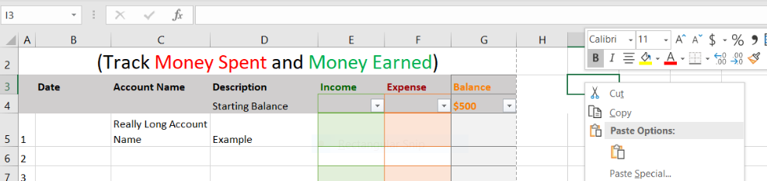

After I copied the selection, I right clicked on cell I3. I am going to click the little clipboard icon under “Paste Options”.

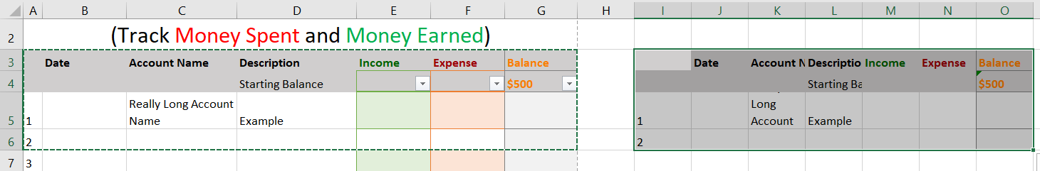

After I click the paste clipboard, I transported a copy of the selection to Cells I3 to O6. Note that even though the copy replicated all the cells, the sizes are different (column width). If I want to make the two sections look exactly the same, I need to change the size of the new cells to match the old ones.

Now we will try to modify the simple ledger on the site (https://www.circlescampaignmov.org/).

Instructions:

- First, download the Simple Ledger from the Microsoft Excel – Custom Budget under the Helpful Tools Tab. Click “Enable Editing” to make changes to the workbook.

- Save the workbook as Template Ledger (you can name it whatever you like).

- Copy cells A3 through G35. This is the whole spreadsheet minus the title at the top. Paste the selection starting in cell A38.

- Change the numbers in the new cells to read 31 through 60 instead of 1 through 30. For example, cell A40 should be 31 instead of 1.

- * Step 5 is to print a copy. Because finding a printer can be challenging, we recommend that you do this step at Circles. (Ask any Circles employee to help you print a copy.)

