Solutions
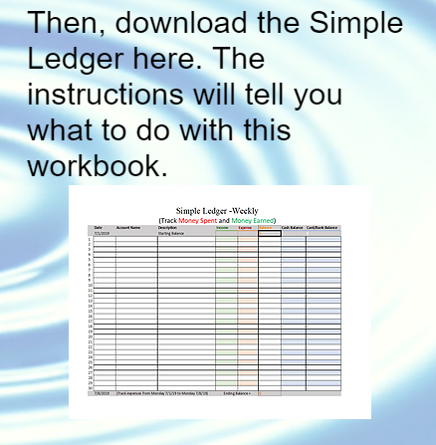
1. Click in the circle (#1) to open the workbook. You
will probably need to find the file and open it - it may
appear in a bar above your start menu. Click the
arrow (#2) and press “Open” in the popup menu.
1

1

2
After you open the workbook, you should see a yellow bar at the top of the screen. Click “Enable Editing”.
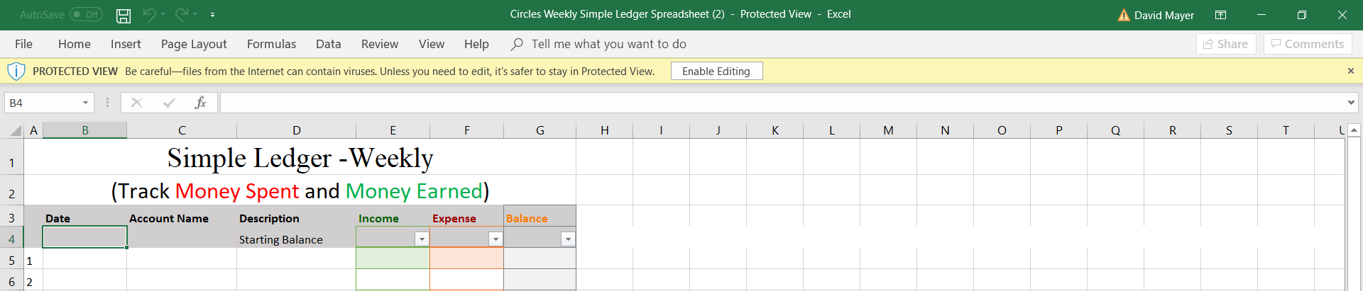

2. In the top corner, click the “File” tab.
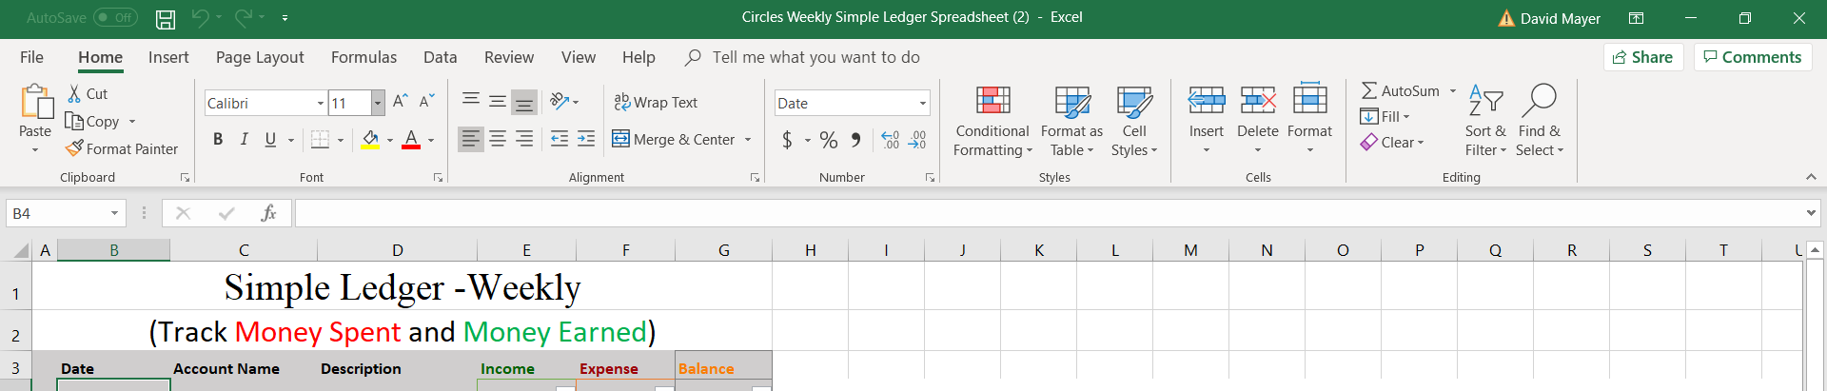

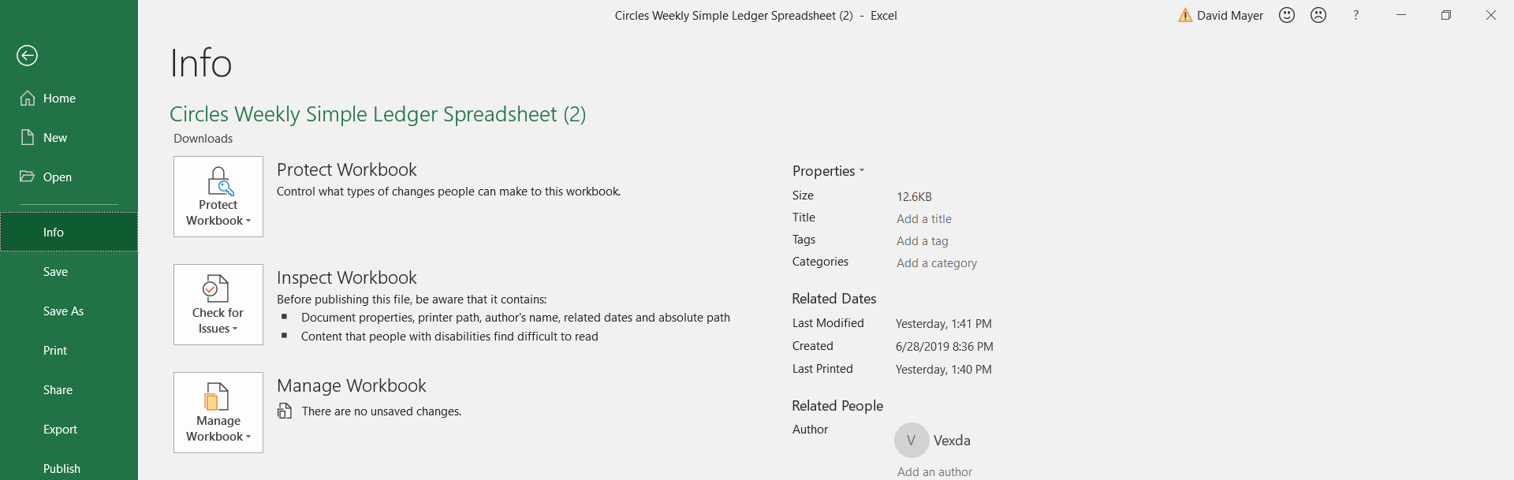

“Save As” appears here on the left side of the screen. Click it to open a new menu.
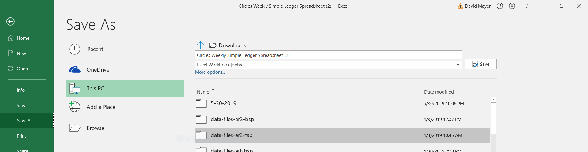
First, type the name of the file into the bar below “Downloads”. Next, click “Save”. Because we saved the file, we can open and print a new copy whenever we want.
3. Click in cell A3 and drag your mouse down to cell G35 without letting go.
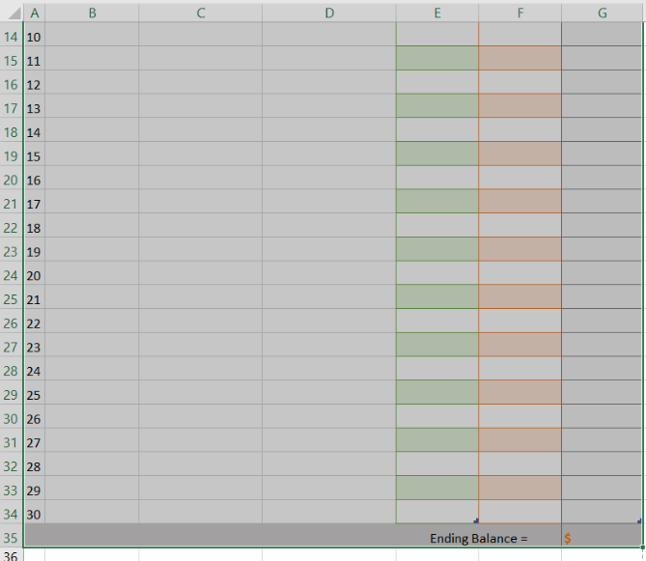
If you click and hold the whole time, you will see your selection highlighted. Let go of the mouse when you have highlighted the correct area.
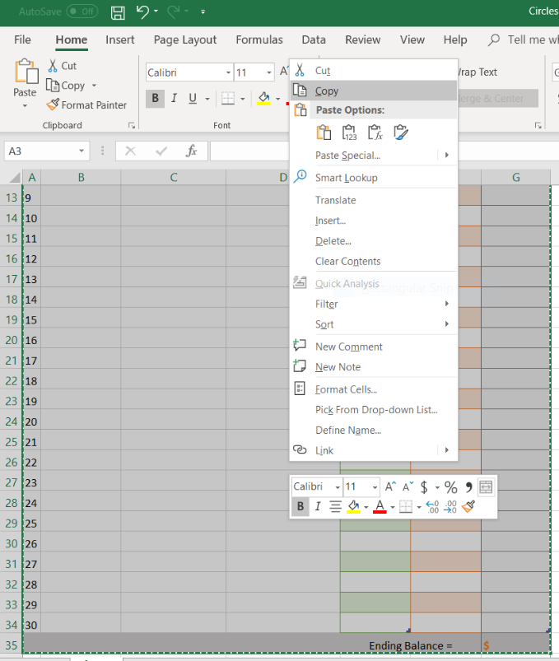
Right click anywhere in the selection and select “Copy”. Then find cell A38.
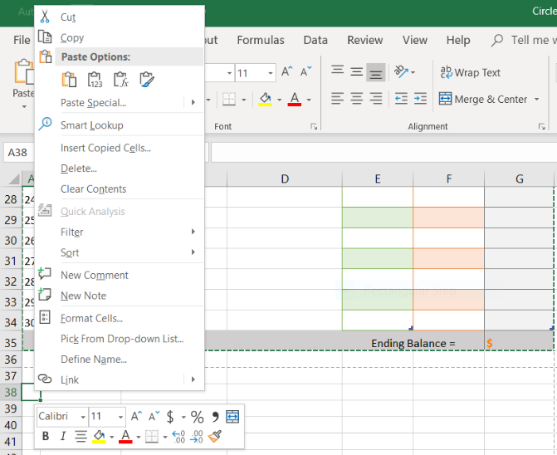
Right click the cell, and click the paste clipboard under “Paste Options:”.
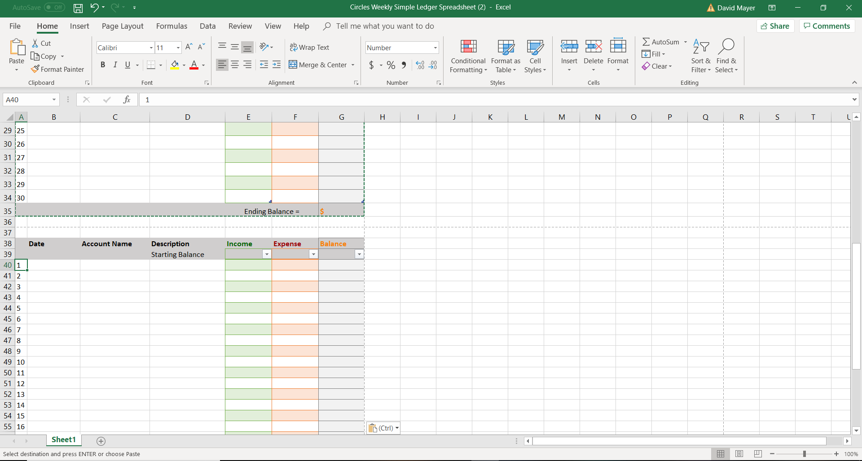
You should see something like this screen above.

4. Find cell A40 and click on it. Press Backspace.
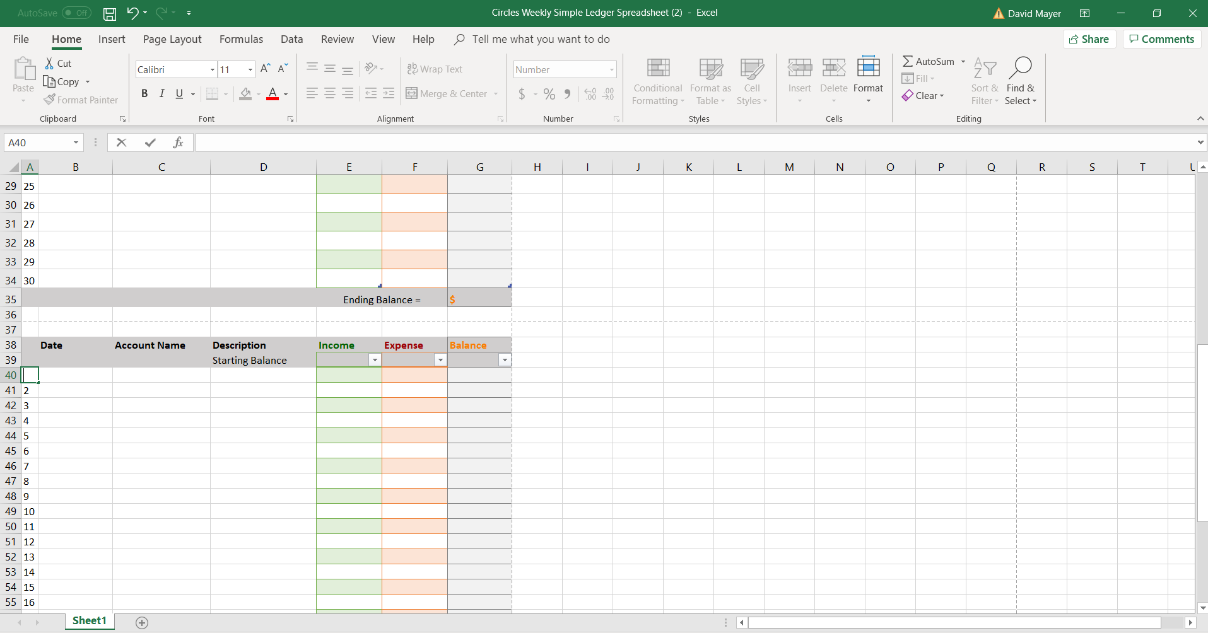
Now type in 31. Move down to the next cell and replace “2” with “32”. Continue until you get to number 60. This is a time-consuming process, but it is easy.
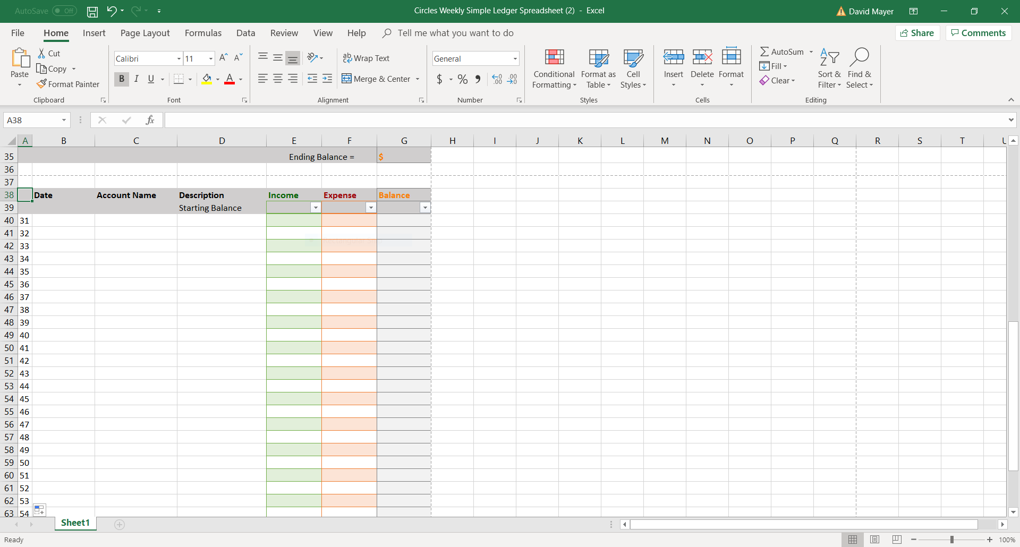
At the end, your workbook should look like this.

5. I’ll show you how I would print this workbook, but results may vary. Some formatting issues can appear when printing from different computers and printers.
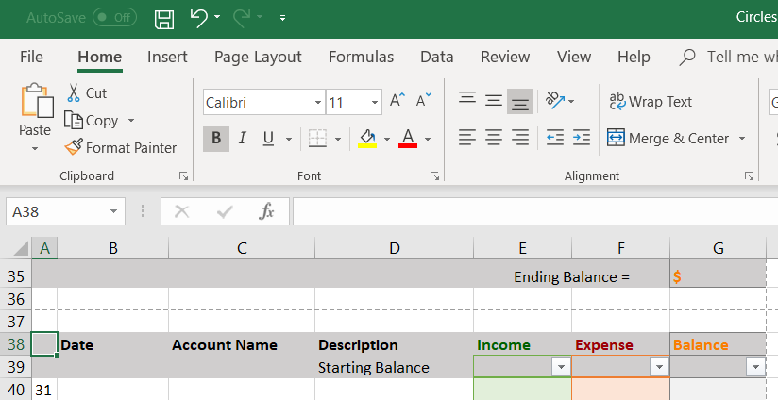
Click the “File” tab.
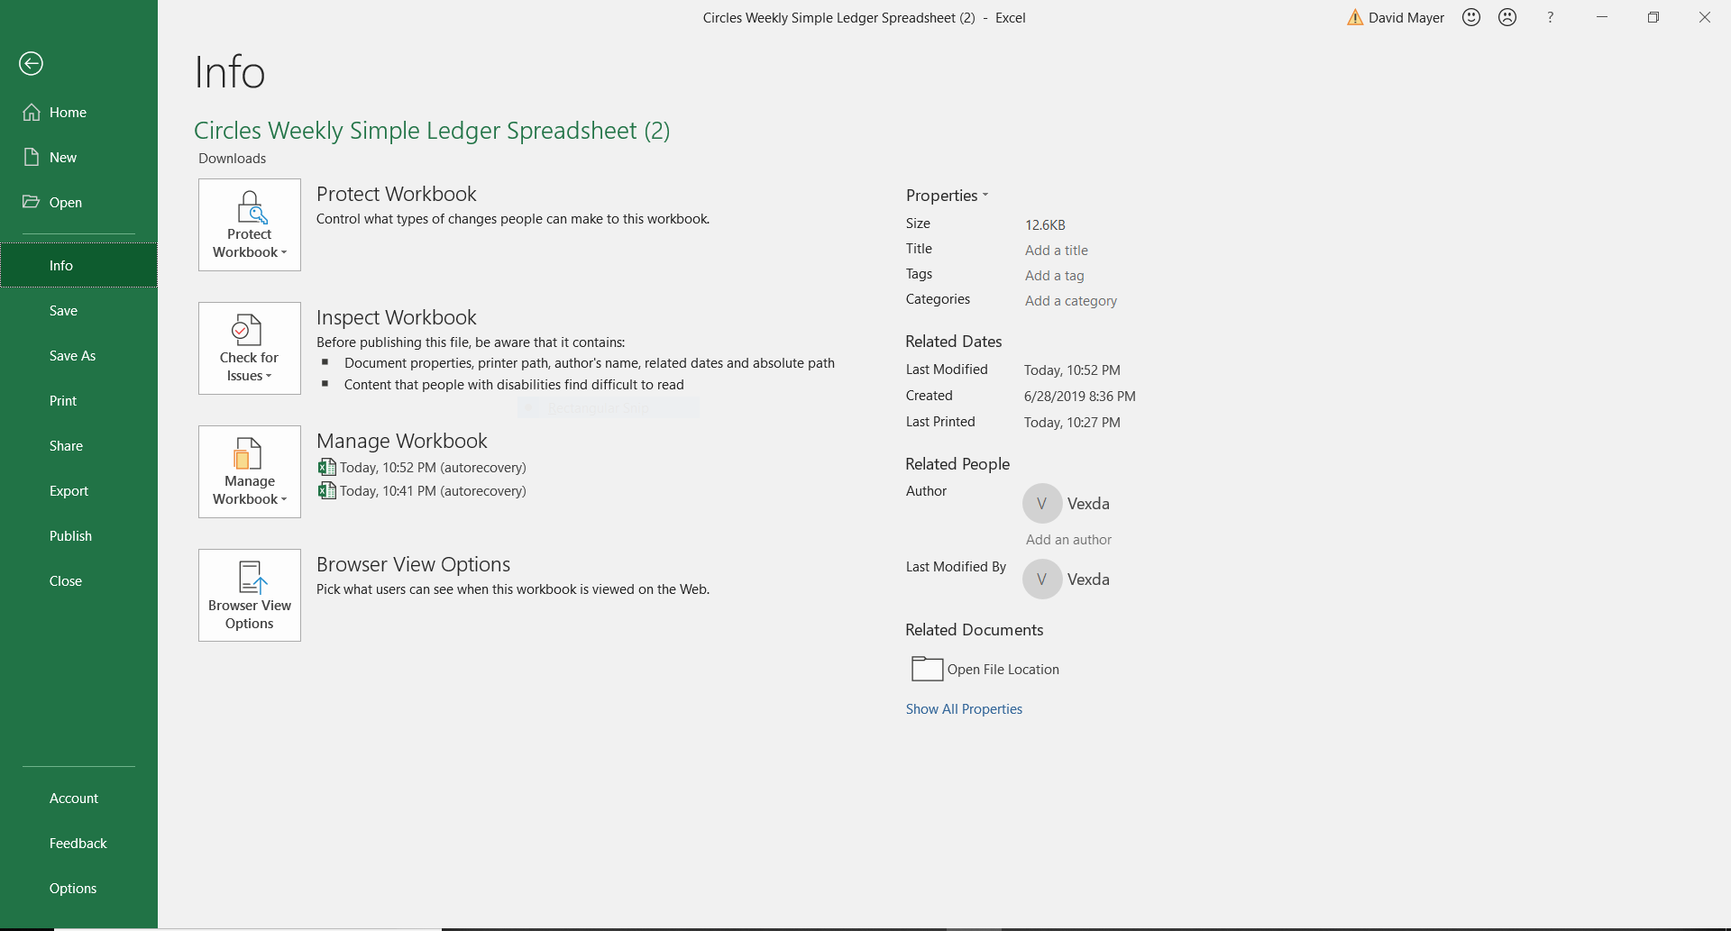
Click “Print”.
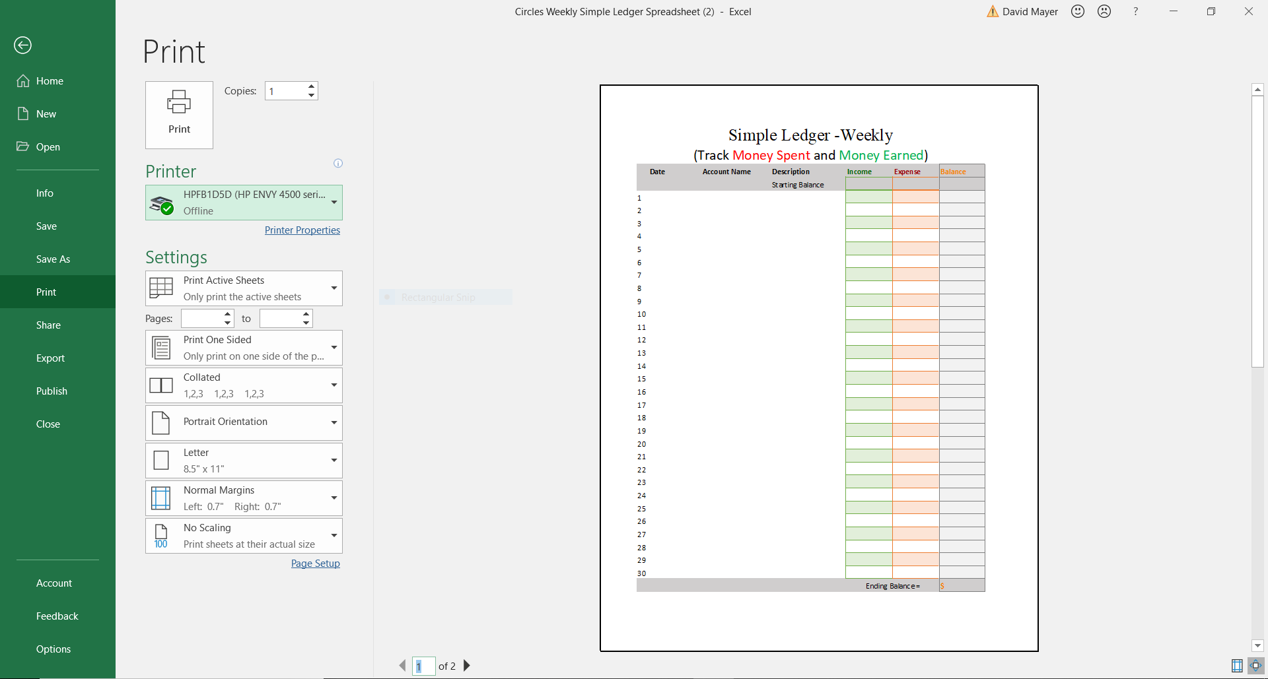
You may have trouble getting your spreadsheet to fit nicely on one page. You may have trouble connecting to a computer. Basically, there are many things that could go wrong. If you want help, try contacting us at Circles.

